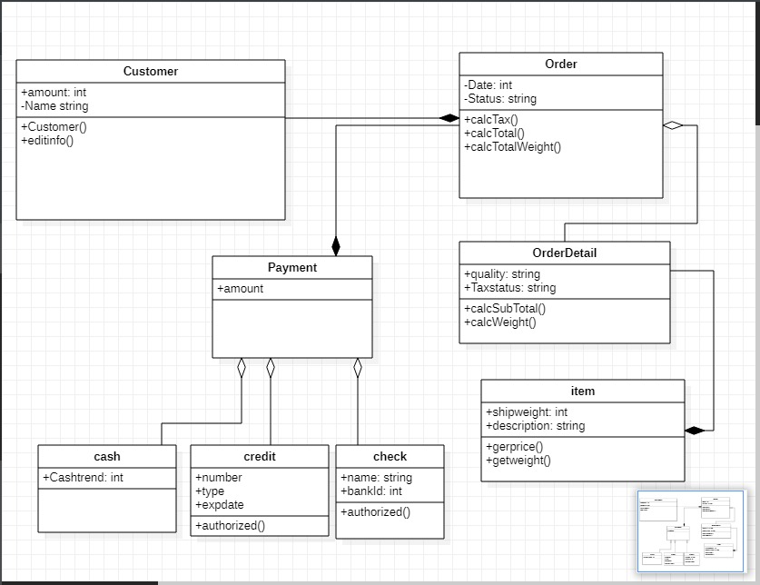

**CLASS : Customer**

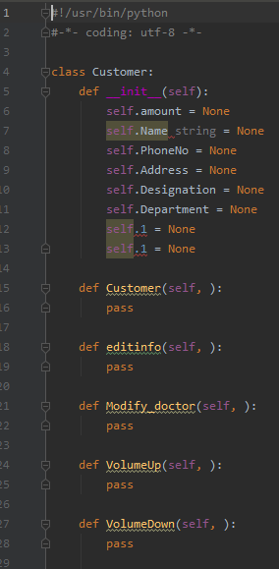

**CLASS : Order**

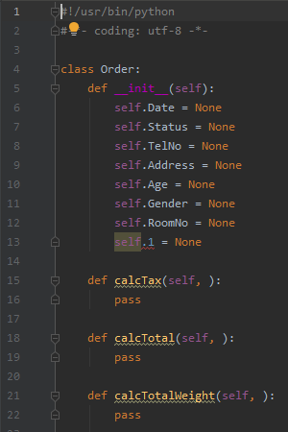

**CLASS : OrderDetail**

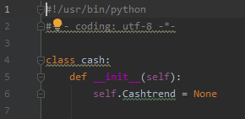

**CLASS : Item**

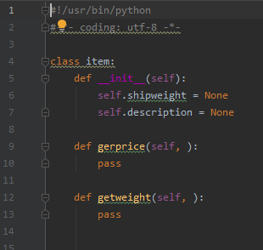

**CLASS : Payment**

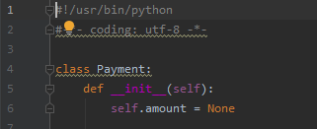

**CLASS : Check**

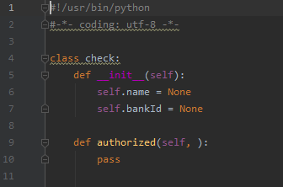

**CLASS : Cash**

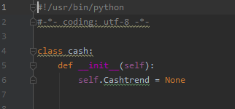

**CLASS : Credit**

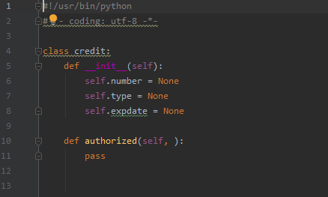

**AGGREGATION:**

Aggregation is an association whose aggregation property is shared.



This shows aggregation.

**COMPOSITION:**

Composition is an association whose aggregation property is composite.

